**Pre-Processing Dataset**

*- Brief summary of your pre-processing strategy*

We have use the preprocessing strategy as mentioned in Lab3.

That is, by normalizing the data by making all the value between 0 and 1.

- Code that you used for pre-processing

maxs = apply(given_Data, MARGIN = 2, max)

mins = apply(given_Data, MARGIN = 2, min)

scaled = as.data.frame(scale(given_Data, scale = maxs - mins))

- It would also be good to include plots for correlation between the various variables and a

histogram the variables showing data distribution

The plots are described below:

***Histogram of how the classes are distributed.***

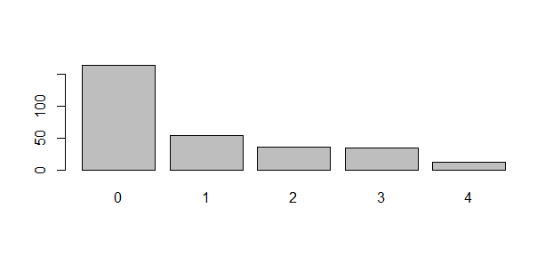

***Correlation matrix for all the attributes:***

